Mobile Applications

CGP605 – AE1

James Coyle – Q13068296

Sean Khanna – Q11279516

Jamie Etting – Q12906735

Xavier Oliver – Q12286257

Level 6

Contents

Design 3

Game Concept 3

Game Mechanics 3

Turrets 3

Level Design 3

Heroes 3

Shop & Gems 3

Save Game 3

Over-world Map 3

Medals & High scores 3

Schedule and Stories 3

Project Management 3

Workload 4

Risk 4

Asset List 5

Appendix 6

Appendix A – HackNPlan 6

Appendix B – Gantt Chart 6

Appendix C – Level Design 8

Appendix D – Use Case 11

OverWorld Screen 11

In Level 11

Appendix E – UI/UX Wireframes 12

Low Fidelity Wireframes 12

High Fidelity Wireframes 16

Appendix F – UML/Class Diagrams 19

Appendix G – Entity Relationship Diagram 19

Appendix H - User Stories 19

Appendix I – GitHub Link 20

Appendix J – Group Risk Assessment 20

Risk List 20

Risk Analysis Matrix 21

Appendix K – Test Plan 21

Overworld 21

Shop 21

Turrets 21

Resources 21

Special Turrets 21

Enemy Ordering 21

Bullets 22

Waves 22

Enemies 22

Time 22

Heroes 22

Abilities 22

End Screen 22

Appendix L– Flow Charts 22

Overworld 23

Pre-level Start 23

Main Game Loop 24

Placing Towers 24

Wave Ai 25

Upgrading Tower 25

Sending Next Wave 26

Check Game Over 27

Appendix M – Turret Behaviour table 27

# Design

## Game Concept

Tower defence game set in space, fighting enemy spaceships and/or aliens, the objective is to protect the base from waves of invading enemies.

## Game Mechanics

The player must use the money they earned from destroy enemies to buy and upgrade towers to help defend their base and defeat more enemies. (Appendix d) allows for an overview of what the player can do while the flow chart (Appendix L) shows how the game is played and reacts to the player.

### Turrets

There are five types of turrets, which all have 3 levels of upgrade: Standard, Laser, Electricity Sniper and Rocket. All can be upgraded a total of three times with their final form offering new abilities such as seeing cloaked enemies, significantly increased damage and stuns. Turrets can only be placed in specific locations allowing use to force the use of specific towers early on with the creation of maps that strongly highlight their benefit.

There are five types of turrets, which all have 3 levels of upgrade (Appendix O). The design of these turrets should allow for a very smooth transition from level 1 to level 5.

### Level Design

The level designs (Appendix C) are focused around turret progression, for example level 1 is focused primarily around the fact that the player is new to the game and only has a basic turret available, and so the design is basic and should be easy for the player to complete.

### Heroes

Heroes are special units that the player can take direct control of. They behave like turrets attacking the enemy unit closest to the exit unless told otherwise. They can also be moved to strategic locations inaccessible to regular turrets for optimum killing potential. These turrets also have special attacks such as grenades and stuns. These units will be chosen before the start of the level and cost nothing to be used. The only way to upgrade a hero character will be through the shop in the overworld menu and not in level like other towers.

### Shop & Gems

Throughout the game the player will be able to acquire gems by completing missions and levels within the game. The players gem counter will be located at the top of screen in-game and in the shop. Players can use these gems to purchase tower upgrades and in-game boosts. Users will also be able to use in-app microtransactions to purchase gems using real money to be used in-game. (Appendix E, High fidelity wireframes, In-game, Shop).

### Save Game

Saving the game will be done via a connection to the database, this will ensure that the save data isn’t modified by the client in any way and will make the high scores leadership board easier.

### Over-world Map

This will be the level select screen done in a classic Mario style where you have a map and a sense of moving location to location before; interconnecting levels in a visually satisfying manner that is more immersive that a simple list of stages.

### Medals & High scores

Medals are earned via completing a level without taking any damage (3 Medals), or without taking more than 50 damage (2 Medals) or having less than 50 health but still being alive, these are then stored in the database under the user's unique device identifier making reclaiming save data and finding the players high score really simple. This is demonstrated in the ERD (Appendix I).

# Schedule and Stories

The Gantt Chart (Appendix B) was created using Project, this has a critical path for the workload in which certain work items must be completed in order to progress. As you can see everyone is catered for based on the WBS and work assignment done a week prior. The sprint dates were purely based on the stakeholder's requirements to have an Alpha, Beta and Prototype phase.

For the planning and documentation section of this work all of the deadlines were met by the team, although I ensured that there were a few days of breathing room to ensure if something goes wrong, we are prepared for it (based on the overall risk assessment, Appendix J). Our HackNPlan (Appendix A) is organised in such a way as to allow an overall view of how the project went via work time logs, which should make scheduling really easy.

# Project Management

For this project we have decided to use a program called HackNPlan (See Appendix A) to help us keep track of what is being done by certain members of the team, how far ahead or behind our deadline we may be and if people are not doing the work. HackNPlan is a program to use for agile style projects, with its features that allow you to create sprints. In aid of HackNPlan **James** also created a Gantt chart to help make sure all deadlines were met and that the workload was spread evenly. To further help us keep track of our work and make sure we don’t lose any work, we used a source control called GitHub, where we could all deposit our pieces of work and know that it is safe.

# Workload

[300 Words]

[Individual]

*Break down of stories assigned to you. This will be a concise description and any further tasks required.*

|  |  |  |  |  |  |
| --- | --- | --- | --- | --- | --- |
| Workload  20% | *Very little or no allocation of workload or unfairly balanced with not rational.* | *Displays an understanding of stories assigned and some basic refining of tasks* | *Displays a well thought out breakdown of the stories and some basic time scales with fair allocation of tasks or rational to explain unfair allocation.* | *As before with more defined scales including dependencies and priorities.*  *Includes a basic critical path.* | *As before, including justification for task allocation and order. Further task refinement and alt critical paths for alternative planes.* |

# Risk

[300 Words]

[Individual]

*Highlight stories that you think may cause problems in the development cycle.*

|  |  |  |  |  |  |
| --- | --- | --- | --- | --- | --- |
| Risk  20% | *No Risks discussed* | *Risks are general and easily solved* | *Risks are linked to user stories or equivalent but no solutions proposed* | *Risks are linked to user stories poor solutions are suggested* | *Well thought out risks that are related to the stories and suitable solutions proposed* |

# Asset List

* UI
  + Buttons
    - General UI button
    - Close button
    - Shop button
    - Menu button
    - Options Button
    - Skip Round Button
    - Pause/Play toggle
    - Daily challenges button
    - Upgrade button(s)
    - Direction arrows
    - Buff buttons
  + Gem Icon
* AI
  + Enemies
    - 5 Types:
      * Slow & Heavy
      * Fast & Light
      * Stealth
      * Splitting
      * Boss
    - Health bar
* Particle Effects
  + Lasers
  + Asteroids
  + Smoke
  + Explosions
* Heroes
* Base
  + Health hearts
* Towers
  + 5 Types:
    - Cannon
    - Lasers
    - Electricity
    - Sniper
    - Rockets
  + Health bar
  + 3 Different upgrade graphics for each
* Space skybox
* Playing fields
* Over-world background
* Tower location placeholders
* Splash screen
* Font
* Logo
* Sounds
  + Death
  + Lasers
  + Combat music
  + Menu music
  + Peace music
  + Movement
  + New wave
  + Menu buttons
  + Buy money
  + Win
  + Lose
  + Rockets
  + Explosion(s)
  + Tower placement
  + Boss music
* Buff icons

# Appendix

## Appendix A – HackNPlan

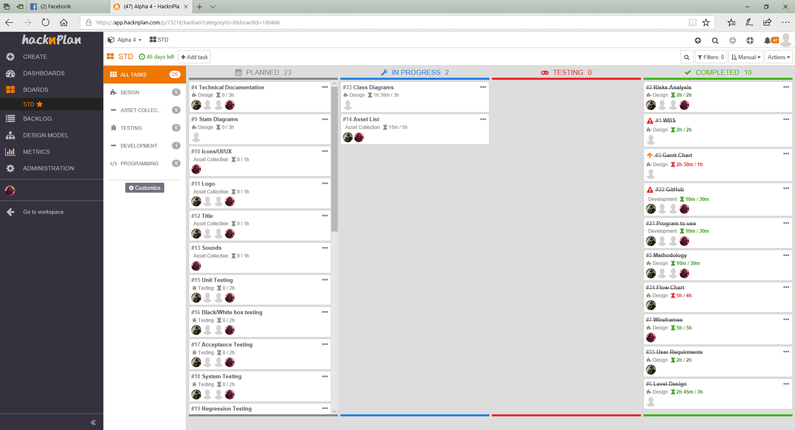

(Access available upon request)

**Appendix created by James Coyle**

## Appendix B – Gantt Chart

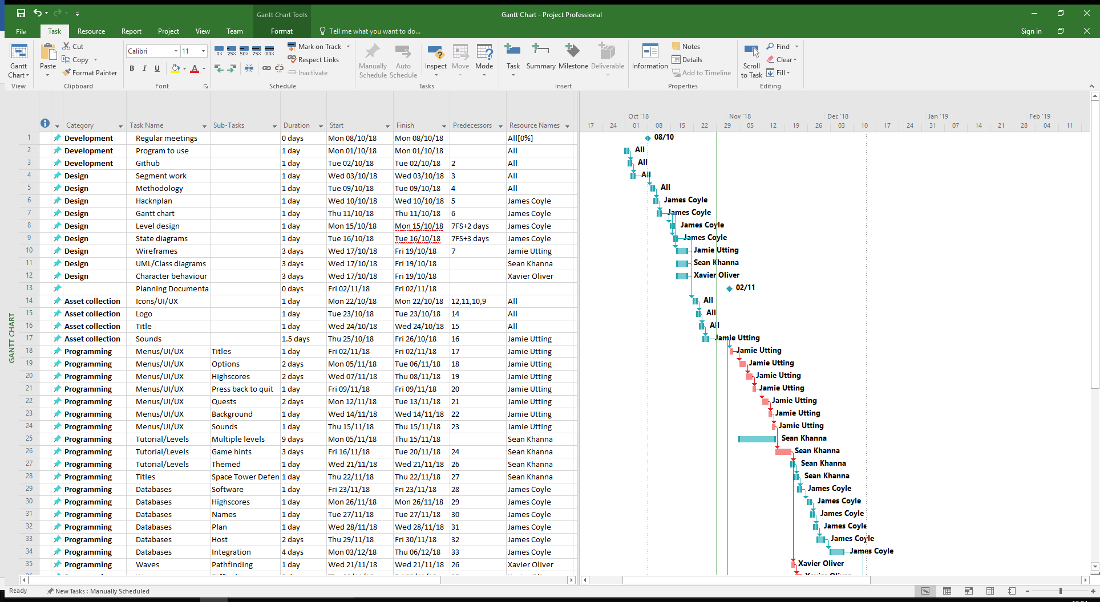 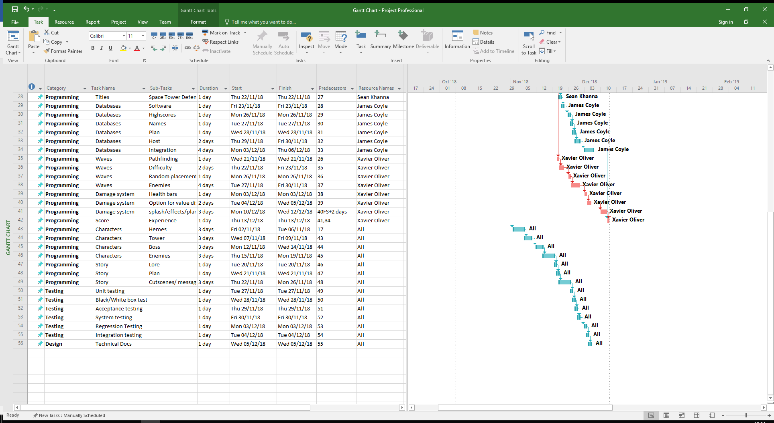

**Appendix created by James Coyle**

Appendix C – Level Design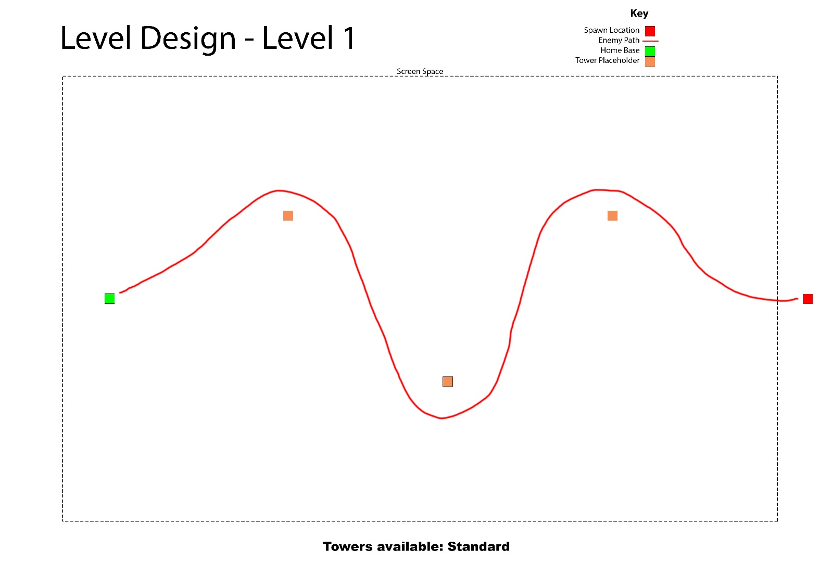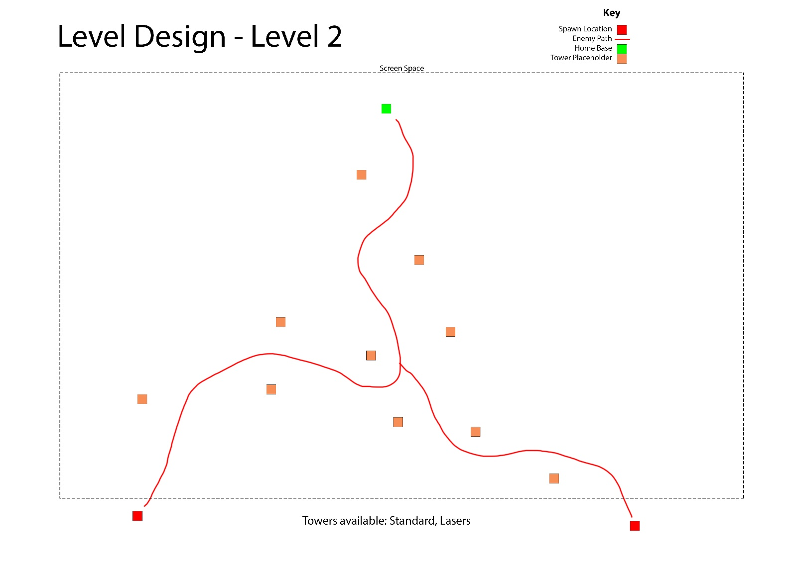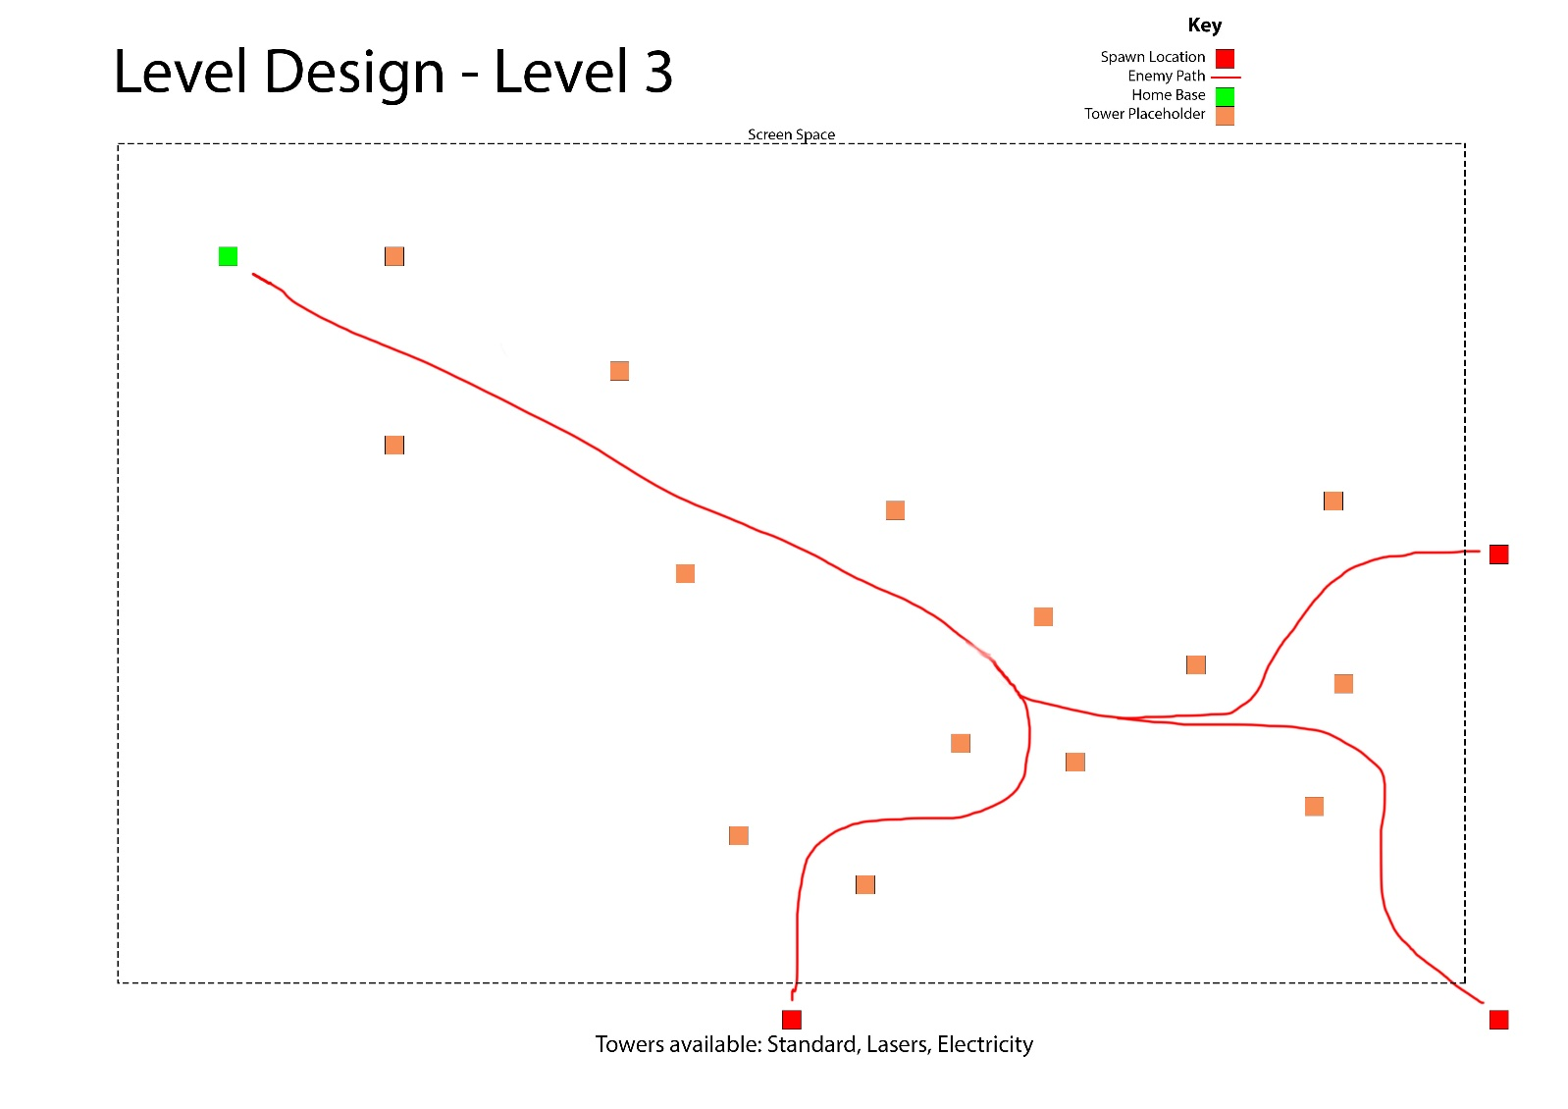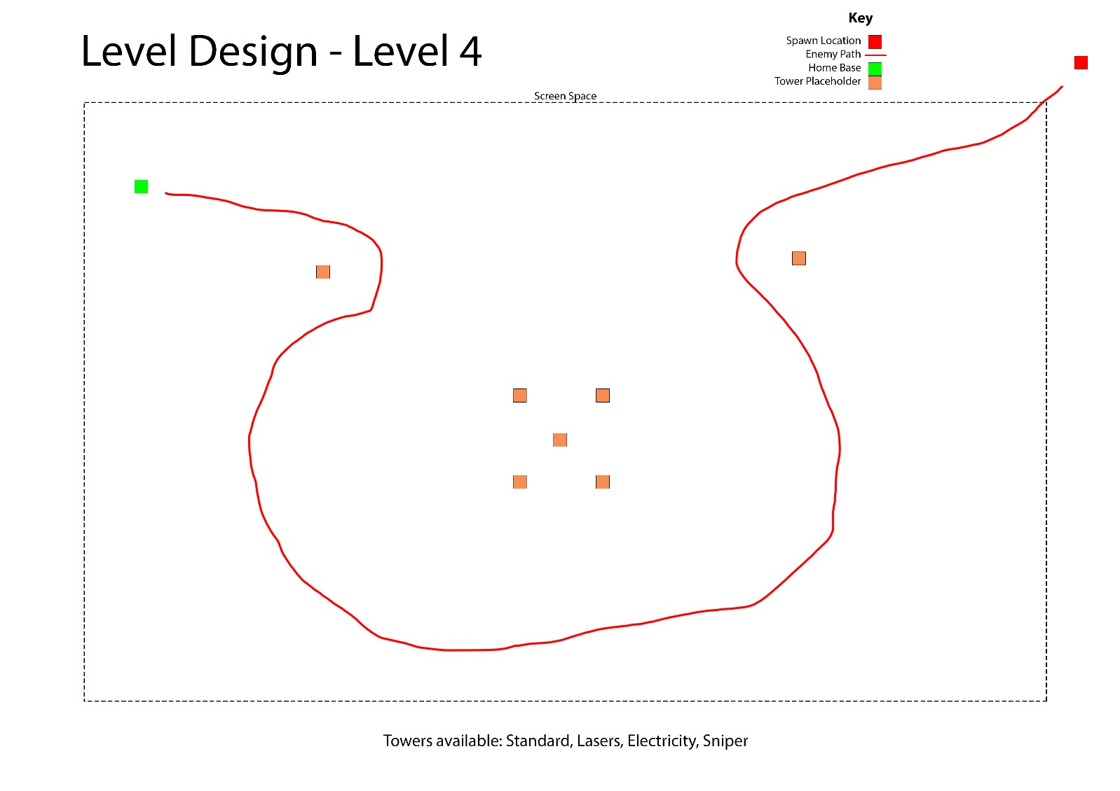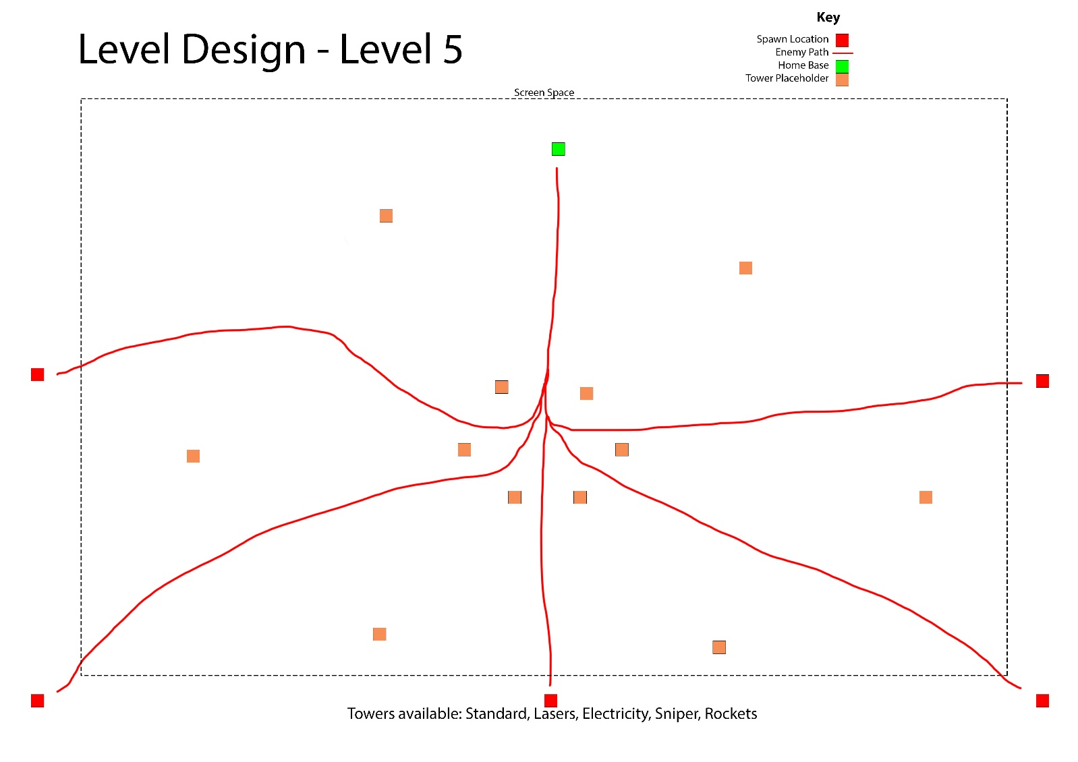

**Appendix created by James Coyle**

## Appendix D – Use Case

### OverWorld Screen

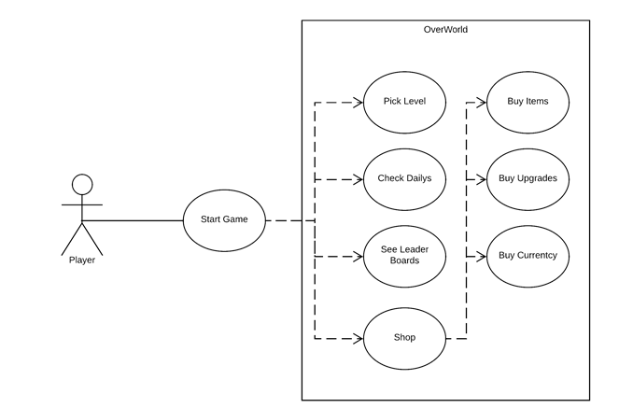

In Level

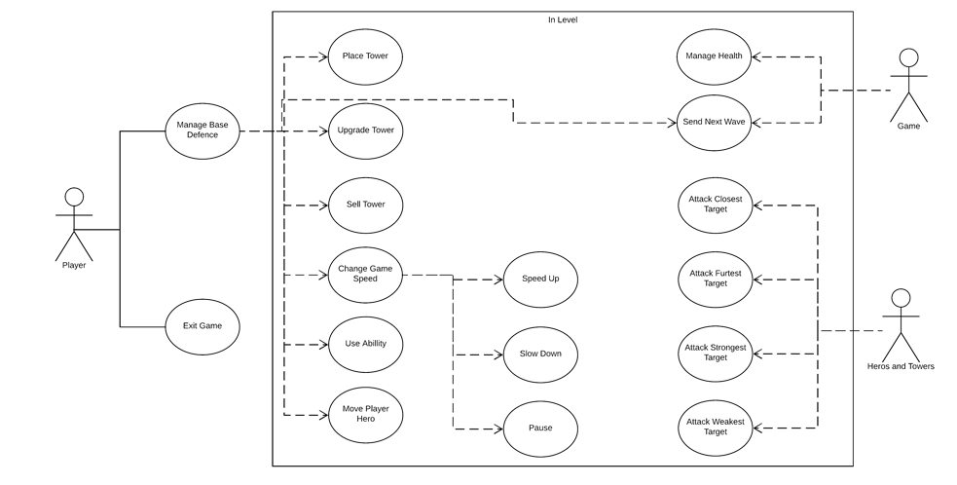

**Appendix created by Xavier Oliver**

## Appendix E – UI/UX Wireframes

### Low Fidelity Wireframes

#### In-Game

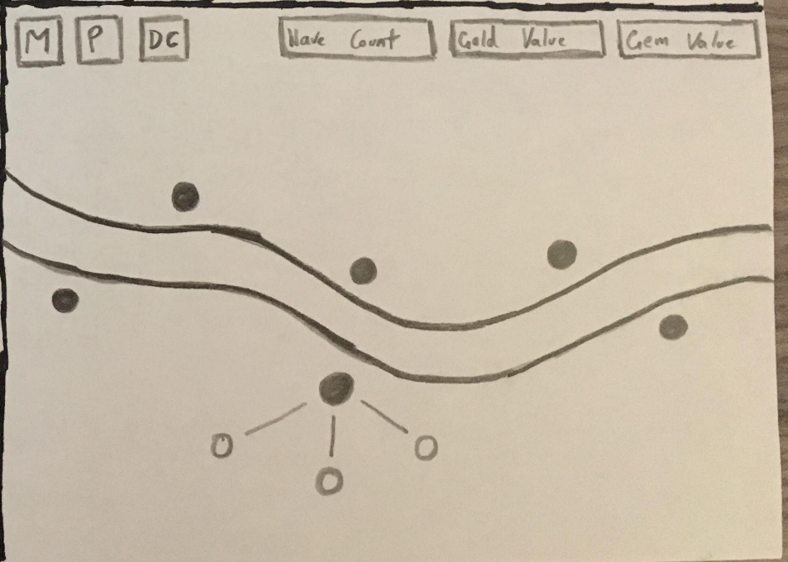

#### Main Menu

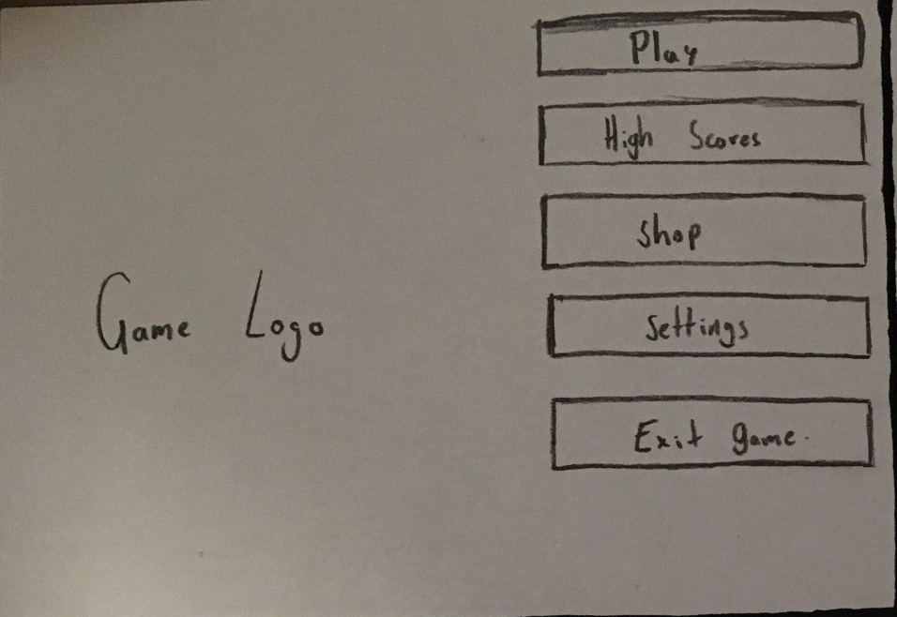

#### Over world Map

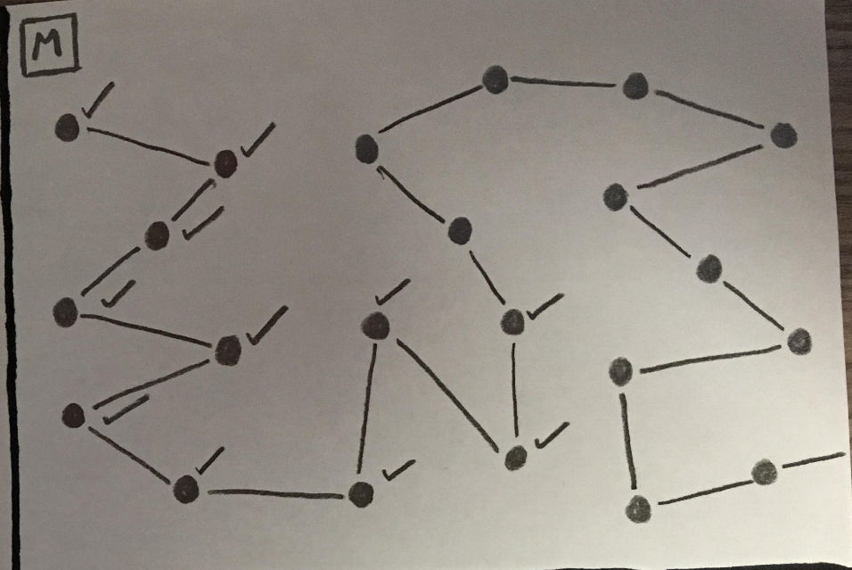

#### Pause Menu

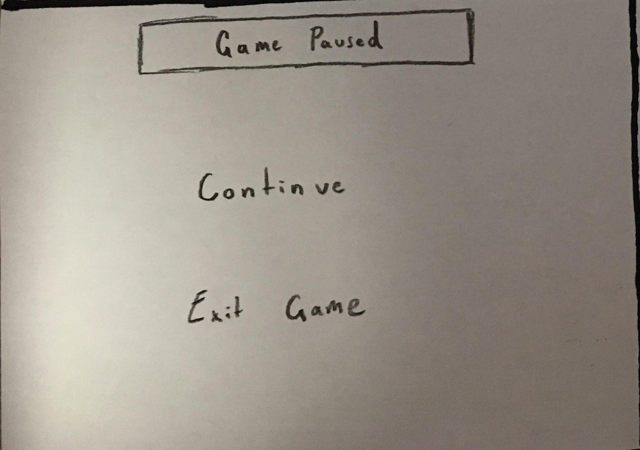

#### Settings

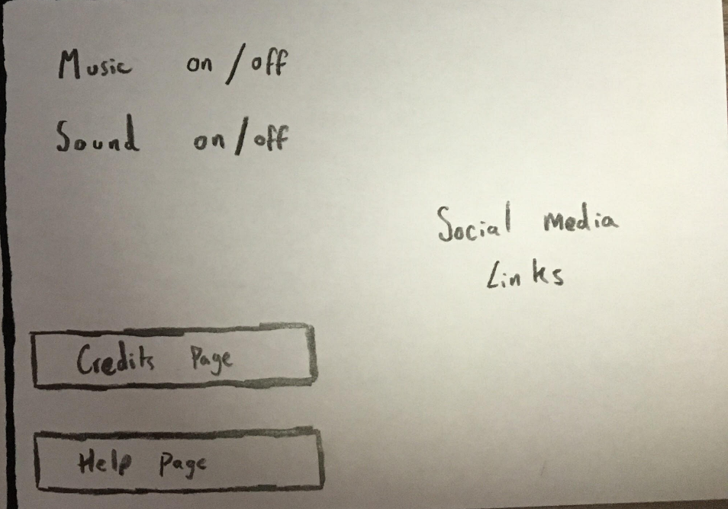

#### Store

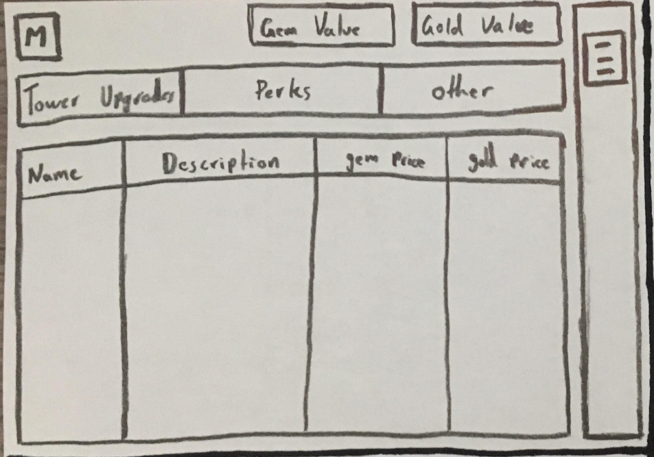

#### Support

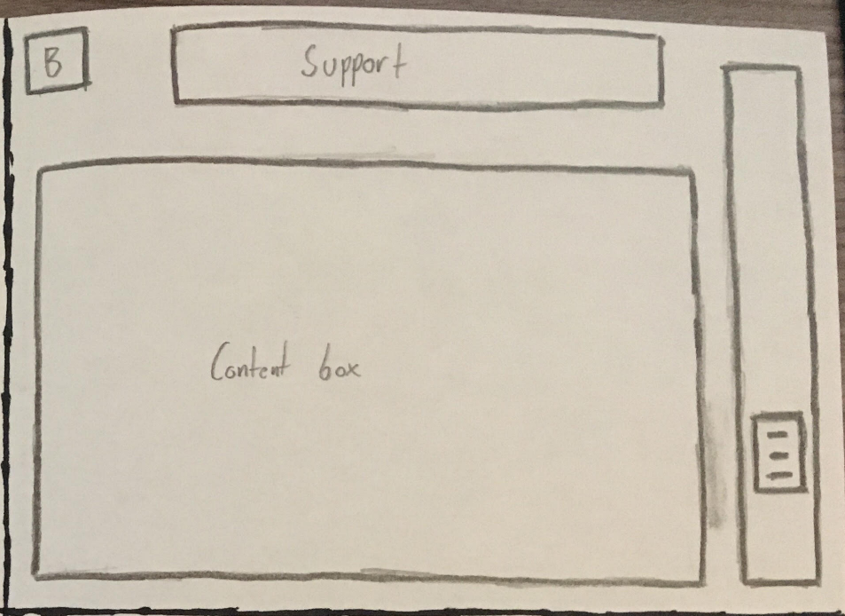

#### Title Screen

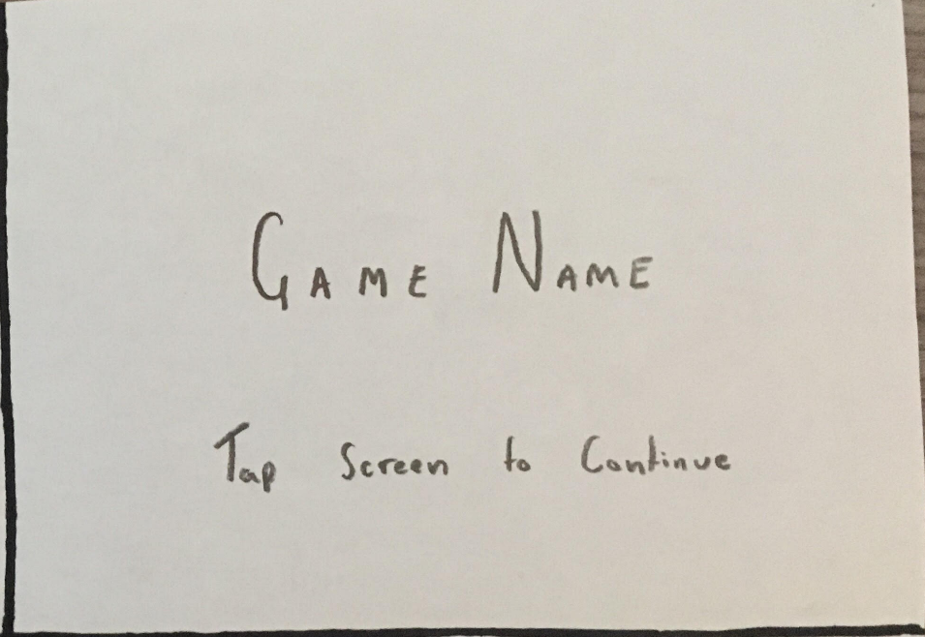

#### Credits

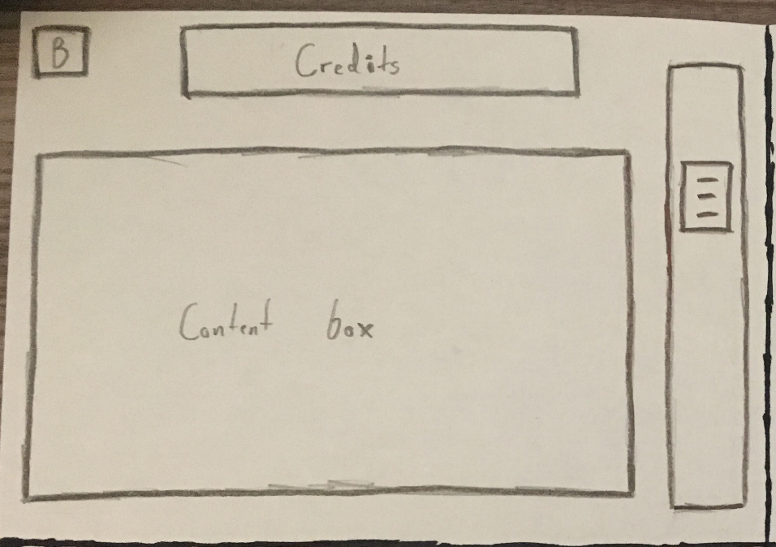

#### High scores

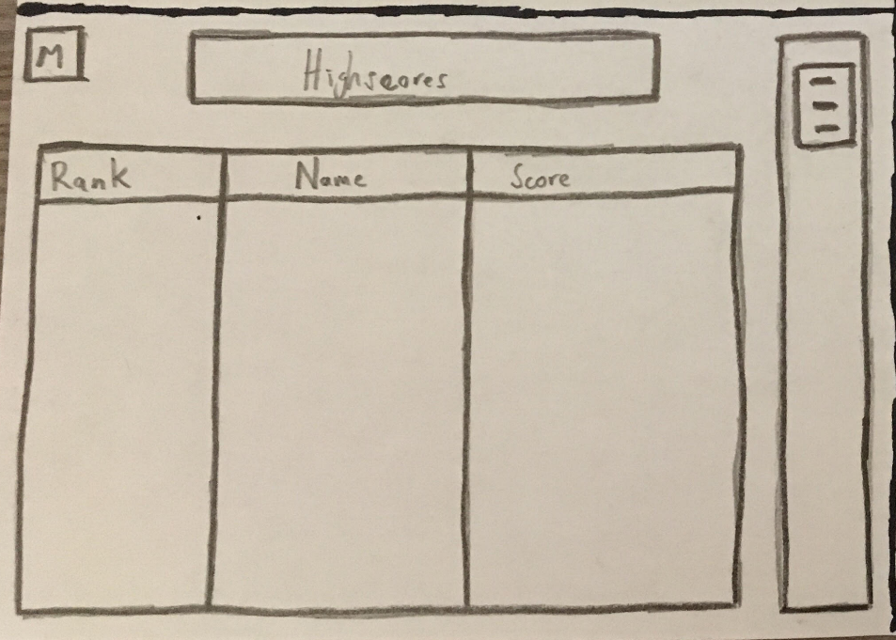

### High Fidelity Wireframes

#### Credits Page

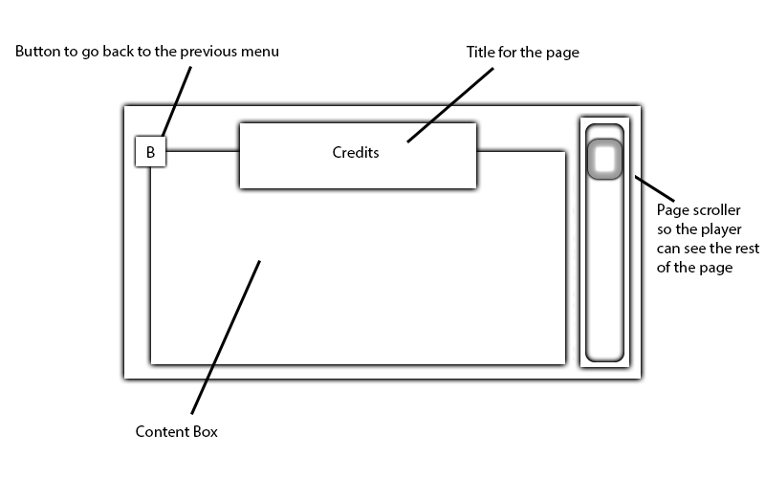

#### Help Page

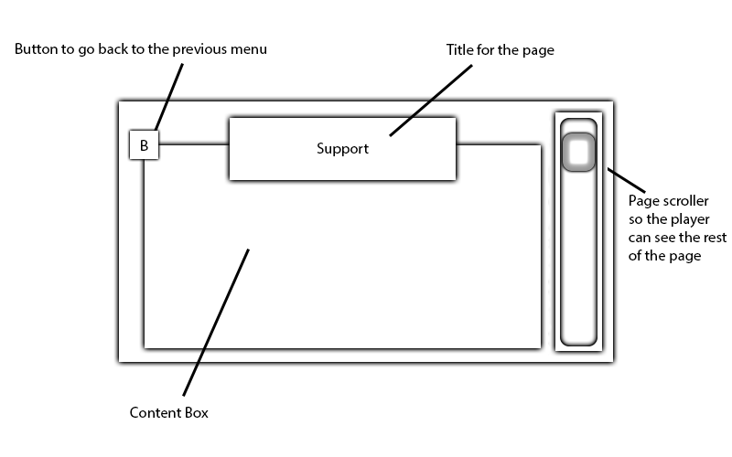

#### High Scores Page

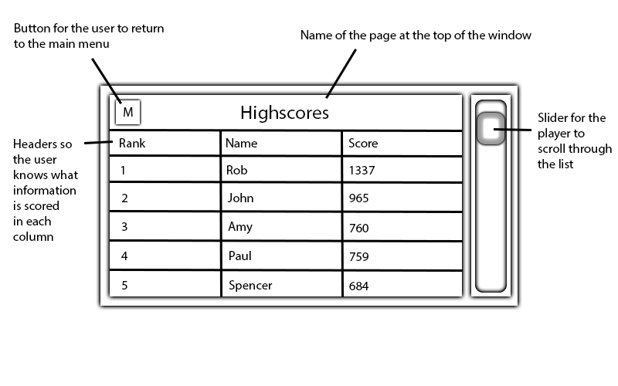

#### In-Game

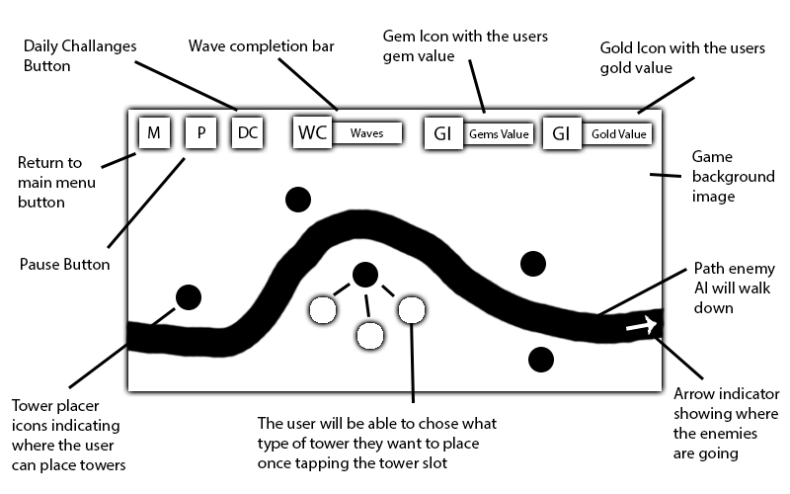

#### Main Menu

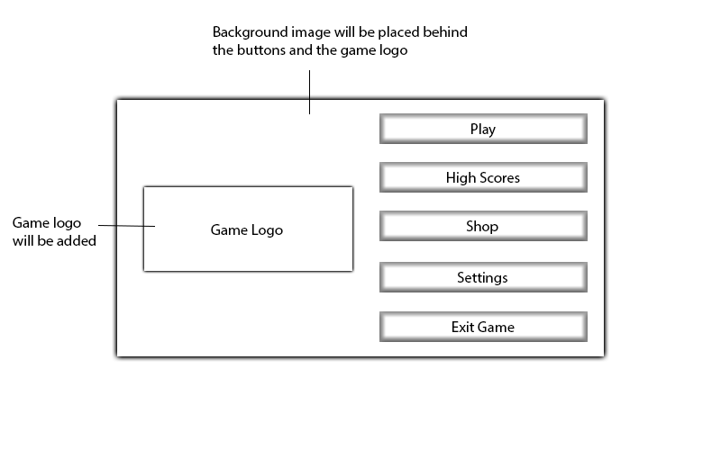

#### Over-world Menu

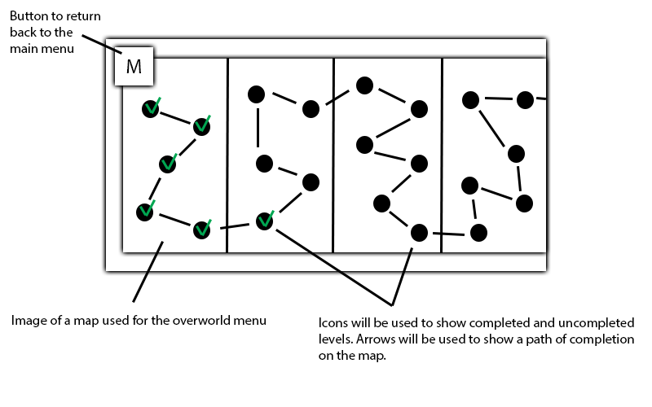

#### Pause Menu

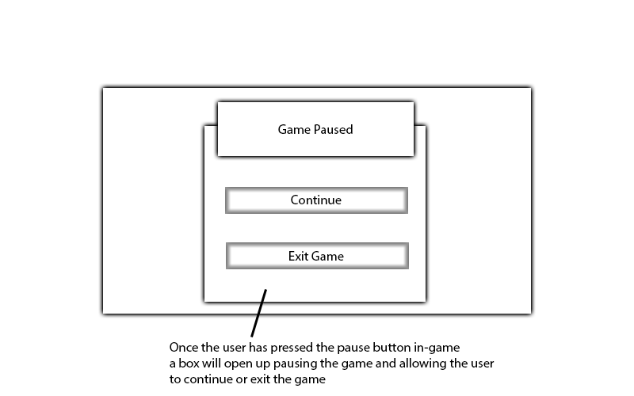

#### Settings Page

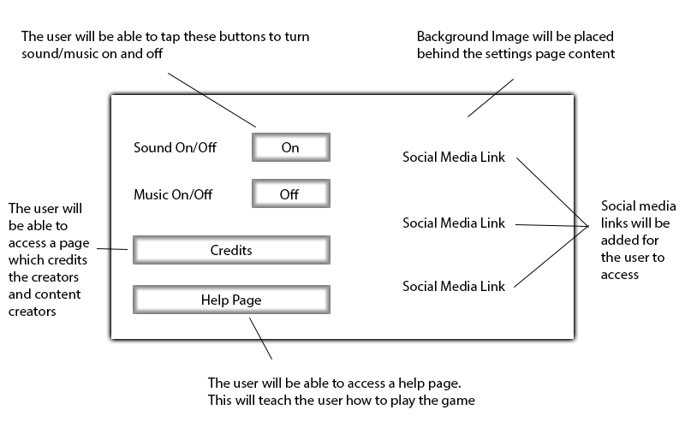

#### Shop Page

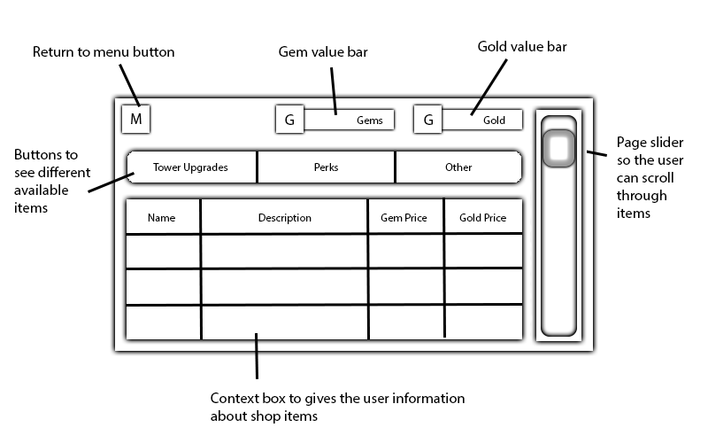

#### Title Page

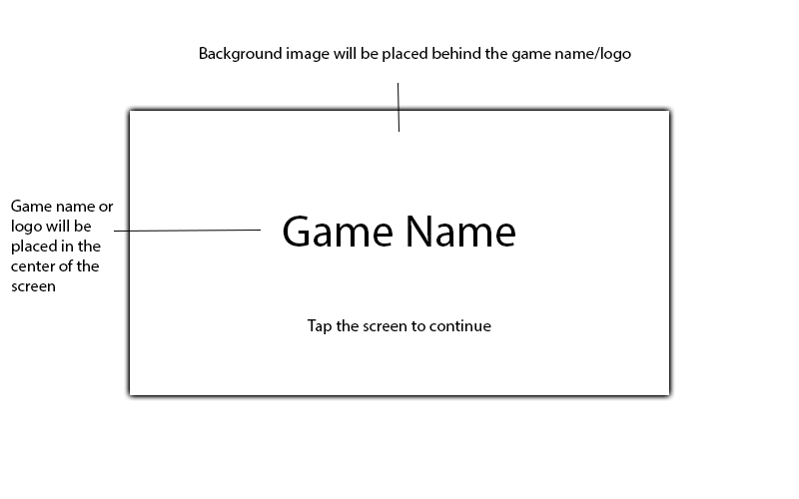

**Appendix created by Jamie Utting**

## Appendix F – UML/Class Diagrams

**Appendix created by Sean Khanna**

## Appendix G – Entity Relationship Diagram



**Appendix created by James Coyle**

Appendix H - User Stories

As a Player I want to be able to pick the level because I want to finish each level with 3 medals.

As a Player I want to be able to check my dailies because I want to earn extra gems every day.

As a Player I want to be able to see a leader board because I want to compete against other players.

As a Player I want to be able to go to a shop because I want to spend my earned gems on items or upgrades etc.

As a Player I want to be able to place a tower so that it can shoot at the enemies.

As a Player I want be able to upgrade my tower because I want it to become stronger and kill my enemies quicker.

As a Player I want to be able to sell my tower because I want to buy a better tower, quicker.

As a Player I want to be able to change the games speed because I want it to move at my pace.

As a Player I want to be able to use an ability so that I can kill my enemies quicker.

As a Player I want to be able to move my hero because I want to place them in a more advantageous spot.

As a Player I want to be able to set the attack target for each tower because I want certain towers to attack certain types of enemies first.

As a Player I want to be able to send the next wave because I feel like I can handle an extra wave.

**Appendix created by Sean Khanna**

## Appendix I – GitHub Link

<https://github.com/KhannaGaming/Mobile-Applications>

**Appendix created by Sean Khanna**

## Appendix J – Group Risk Assessment

### Risk List

1. Illness
2. Traffic
3. Loss of work
4. Loss of Internet
5. Procrastination
6. Loss of family members
7. University software issues
8. Synchronizing software
9. Hardware failure
10. GitHub failure
11. Team member goes missing
12. Discord failure
13. Facebook failure
14. Phone/tablet hardware failure
15. Theft
16. Falling out with team members
17. Christmas (Holidays)
18. Birthdays
19. External software issues
20. Collaboration
21. Communication
22. Part time work
23. Social Life
24. Lack of understanding
25. Lack of testing
26. Lack of direction
27. Lack of planning
28. Family
29. Nick taking time off
30. Power failure

### Risk Analysis Matrix

|  |  |  |  |  |
| --- | --- | --- | --- | --- |
|  |  | Likelihood of Risk | | |
|  |  | 1 | 2 | 3 |
| Severity | 1 | Loss of Interest  Discord Failure  Facebook Failure  Phone/tablet hardware failure  Nick taking time off | Traffic  Lack of understanding | Illness  Synchronizing software  Christmas (Holidays)  Birthdays |
| 2 | Theft  Lack of planning | External software issues  Collaboration  Lack of direction | Procrastination |
| 3 | Loss of family members  Hardware failure  GitHub failure  Team member goes missing  Falling out with team members  Communication  Power Failure | Loss of work  University software issues  Family | Part time work  Social Life  Lack of understanding |

Appendix K – Test Plan

### Overworld

|  |  |  |
| --- | --- | --- |
| Overworld | Success | Fail |
| Player can select level |  |  |
| Selected level displays map |  |  |
| Selected level displays map rating |  |  |
| Selected level displays friends high scores |  |  |
| Level loaded when play is clicked |  |  |

### Shop

|  |  |  |
| --- | --- | --- |
| Shop | Success | Fail |
| Player can buy currency |  |  |
| Buying currency increases amount of currency |  |  |
| Player can unlock upgrades with correct amount of money |  |  |
| Money is decreased by amount spent after purchase |  |  |

### Turrets

|  |  |  |
| --- | --- | --- |
| Turrets | Success | Fail |
| Can the Player place turrets on unoccupied spaces |  |  |
| Can the Player Upgrade Turrets |  |  |
| Does upgrading the turrets change their damage |  |  |
| Does upgrading the turrets change their model |  |  |
| Do turrets face the direction they shoot |  |  |
| Do the fire rate modifiers increase / decrease rate of fire |  |  |

### Resources

|  |  |  |
| --- | --- | --- |
| In Game Resources | Success | Fail |
| Lack of funds prevent spending |  |  |
| Lack of space mana prevents abilities |  |  |
| Money goes up when enemies a killed |  |  |
| Money goes down when spent |  |  |
| Space Mana goes up over time |  |  |
| Space mana is used on special attacks |  |  |
| Health is decreased depending on the enemy type let through |  |  |
| 0 health and below results in end screen |  |  |

### Special Turrets

|  |  |  |
| --- | --- | --- |
| Special turrets | Success | Fail |
| Only special turrets fire on clocked enemies |  |  |
| Does Electric turret chain to other enemies |  |  |
| Is chain damage calculated correctly |  |  |
| Do Rocket towers damage in the correct area |  |  |
| Is Splash damage consistent |  |  |

### Enemy Ordering

|  |  |  |
| --- | --- | --- |
| Enemy Ordering | Success | Fail |
| Enemies are ordered based on how close they are to the end point |  |  |
| Can turrets fire at the closets enemy |  |  |
| Can turrets fire at the furthest enemy |  |  |
| Can turrets fire at the Strongest enemy |  |  |
| Can turrets fire at the Weakest enemy |  |  |

### Bullets

|  |  |  |
| --- | --- | --- |
| Bullets | Success | Fail |
| Are Bullets fired form the correct place |  |  |
| Do bullets hit the correct target |  |  |
| Do bullets always hit an active target |  |  |
| Do bullets stop when there enemy disappears |  |  |
| Do bullets make 'spark' on hit |  |  |
| Do bullets do correct damage |  |  |

### Waves

|  |  |  |
| --- | --- | --- |
| Waves | Success | Fail |
| Are enemies wave sent at correct intervals |  |  |
| Are enemies in waves sent at correct intervals |  |  |
| Do Enemies populate the order list correctly |  |  |
| Do enemies modify the order list correctly |  |  |

### Enemies

|  |  |  |
| --- | --- | --- |
| Enemies | Success | Fail |
| Move towards exit |  |  |
| Follow path played out |  |  |
| Do enemies take correct damage |  |  |
| Does death effect happen below 1 health |  |  |
| Is unit removed at below 1 health |  |  |
| Stop moving on electric attacks |  |  |
| Are enemies removed when they reach exit |  |  |

### Time

|  |  |  |
| --- | --- | --- |
| Time | Success | Fail |
| Can Game Time be speed up |  |  |
| Can Game Time be paused |  |  |
| Can game time be reverted to normal |  |  |

### Heroes

|  |  |  |
| --- | --- | --- |
| Heroes | Success | Fail |
| Can be moved via waypoint |  |  |
| Waypoint created by screen tap |  |  |
| Fire On enemies (uses turret algorithm) |  |  |

### Abilities

|  |  |  |
| --- | --- | --- |
| Abilities | Success | Fail |
| Deploys when clicked |  |  |
| Plays correct effect |  |  |
| Plays relevant animation |  |  |
| Has correct range |  |  |
| Does correct damage |  |  |
| Orbital laser |  |  |
| Can be moved after creation |  |  |
| Emp |  |  |
| EMP stops enemies caught in blast |  |  |
| Miniature Nebula Persists on map for correct time |  |  |
| Miniature Nebula Slows and damages enemies |  |  |

End Screen

|  |  |  |
| --- | --- | --- |
| End Screen | Success | Fail |
| Correctly calculates rank |  |  |
| Saves High score |  |  |
| retry button reloads level |  |  |
| Exit returns to overworld |  |  |

**Appendix created by Xavier Oliver**

Appendix L– Flow Charts

### Overworld

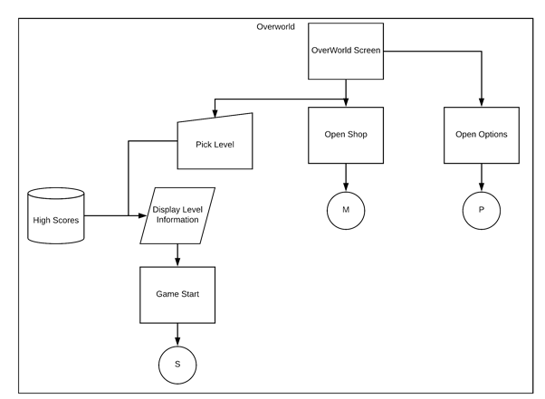

### Pre-level Start

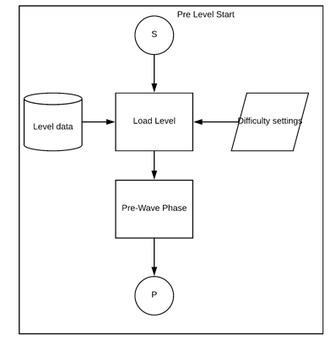

### Main Game Loop

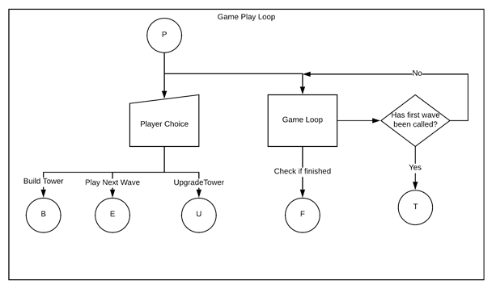

### Placing Towers

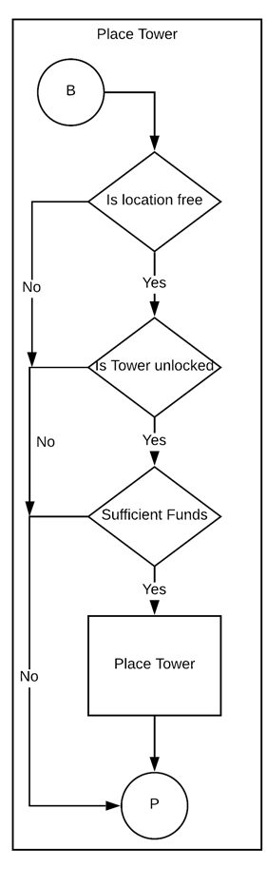

### Wave Ai

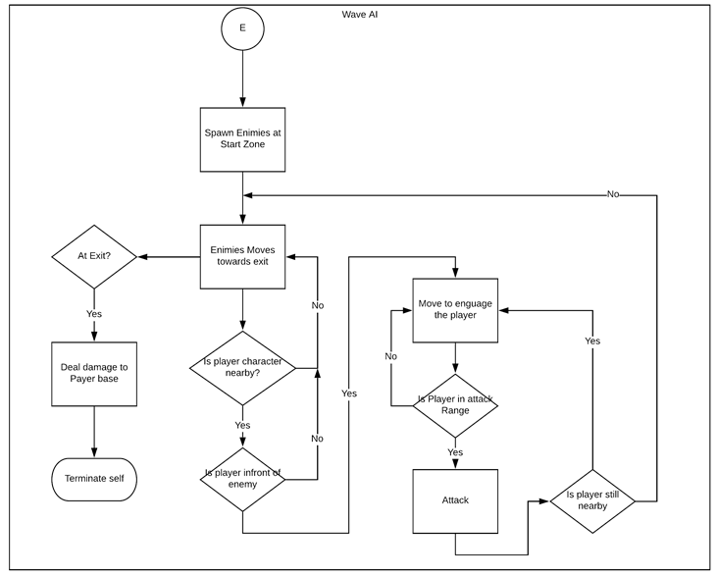

### Upgrading Tower

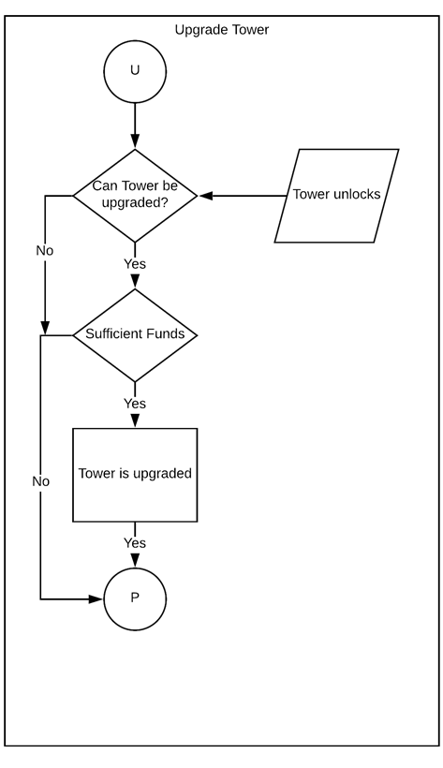

### Sending Next Wave

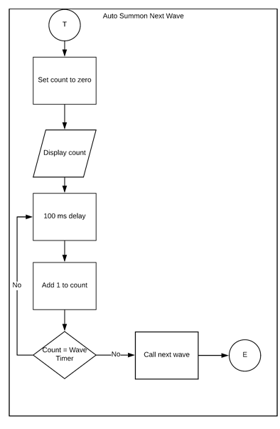

### Check Game Over

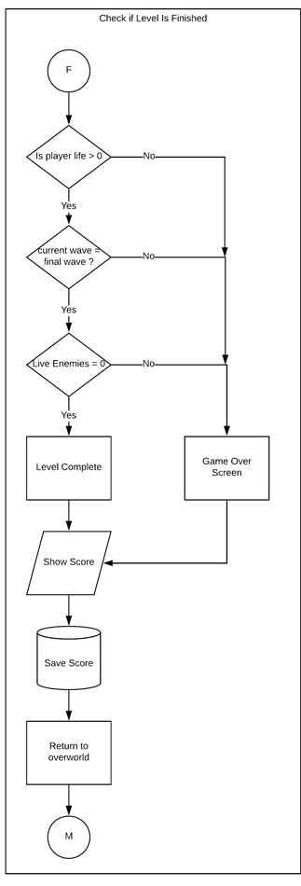

**Appendix created by Xavier Oliver**

Appendix M – Turret Behaviour table

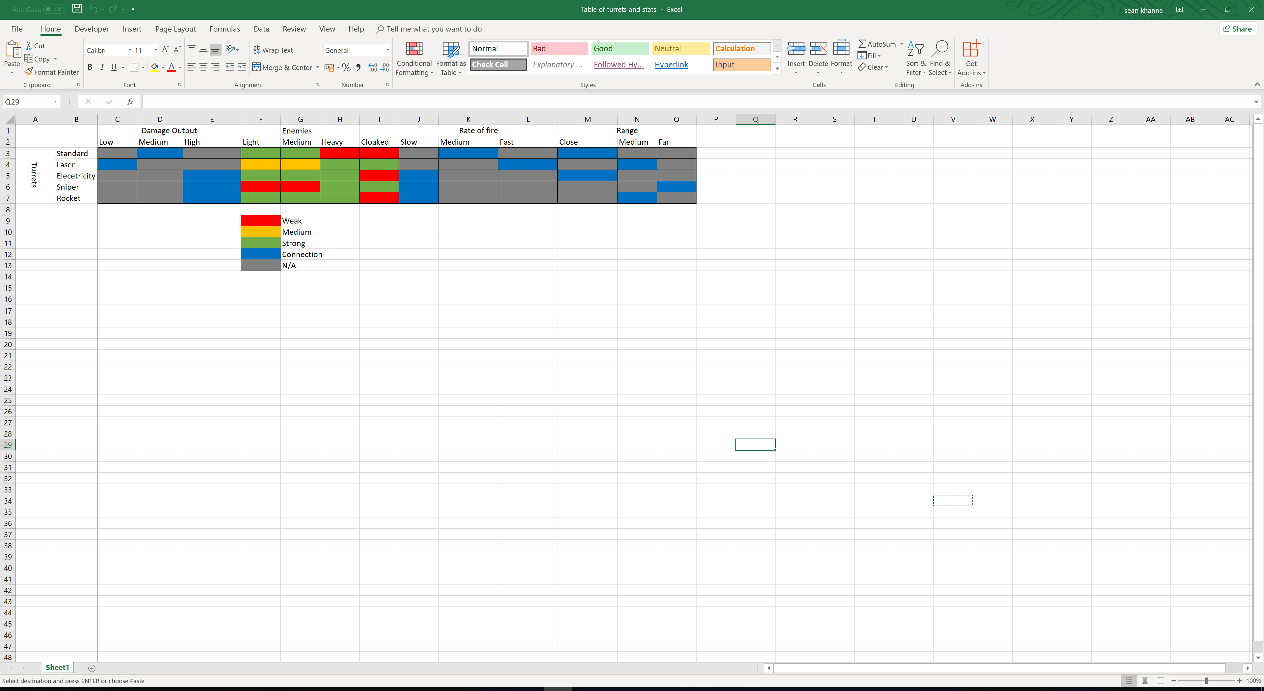

**Appendix created by Sean Khanna**